Computer Lab Midterm Exam
27.11.2020
1) D Flip flop shown in figure. Complete the given verilog code below. Fill the code with given ……… blanks.

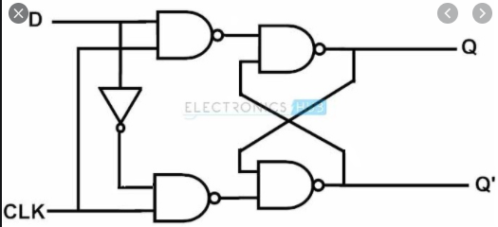

module dff (clk, reset, d, q, qb);
input clk;
input reset;
input d;
output q;
output qb;

reg q;

assign qb = ~q;

always @(posedge clk or posedge reset)
begin

if (reset) begin
// Asynchronous reset when reset goes high
q <= 1'b0;
end else begin
q <= d;
end
end
endmodule

2) Write the code for “case” code part for 4x1 mux.
module mux4x1 (sel, a, b, c, d, o);
input [1:0] sel;
input a, b, c, d;
output reg o;
always @(sel or a or b or c or d)
begin
case(sel)
2'b00:o <=a;
2'b01:o <=b;
2'b10:o <=c;
2'b11:o <=d;
endcase
end
endmodule

